Alex Plunkett

MCTV Limited  Limerick

Microsoft Dynamics User Guide.

* **Contents.**
* **Welcome to the user guide.**
* **Microsoft Dynamics.**
* **Basics**

**Welcome.**

This user guide aims to instil the basics of using the cloud-based service Microsoft Dynamics 365 CRM, ERM software allowing for an increase to the speed new users are able to work with the system.

**Microsoft Dynamics.**

Upon setting up your account, for a package or just a trial, you will be greeted by the home screen.

There are four main tabs on the home 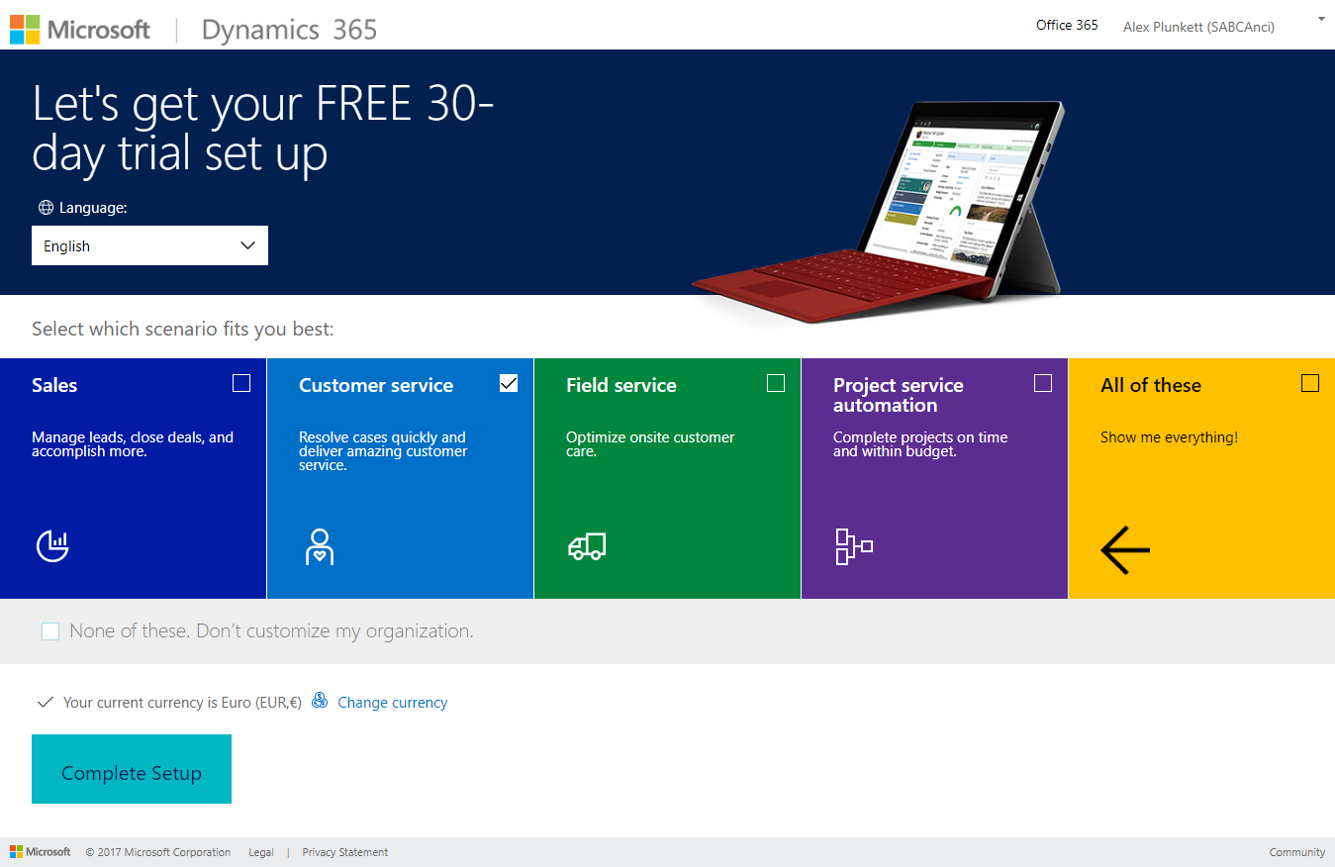screen these are labelled as scenarios and are labelled as

Sales

Customer Service

Field Service

Project Service Automation

As the main focus of this guide and the preceding report is the CRM aspect of the software we select customer service.

We are then greeted by a dashboard featuring a number of graphs related to Customer relations management.

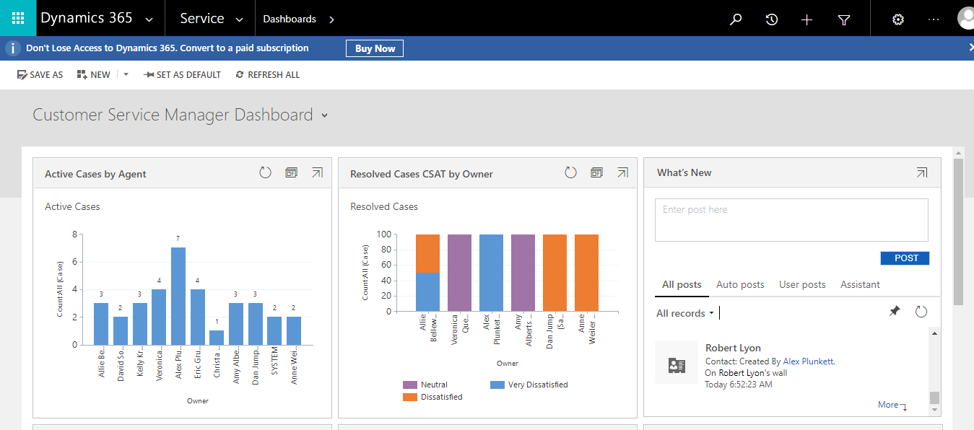

Then we have the top bar which features settings, help and access to your account features as expected.

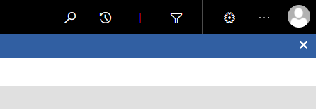

It also features a few other features including.

New: symbolised by a plus allows for new information to be added

Advanced find: allowing for the creation of search queries.

Recently viewed items symbolised by a clock.

Finally, there is search symbolised by a magnifying glass

There are a few drop down menus available to use such as from the services section of the top bar.

This allows access to a number of important features such as settings, training and customers accounts.

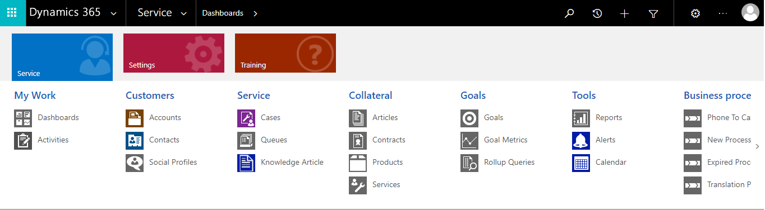

Also a menu allowing access to a number of applications including OneDrive, Word and Excel.

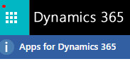

Unfortunately, I was unable to get a screenshot of this menu as it would close before the screenshot could be taken.

Finally, we have a drop down menu from the title customer relations management that opens up to a number of other potential roles and viewpoints.

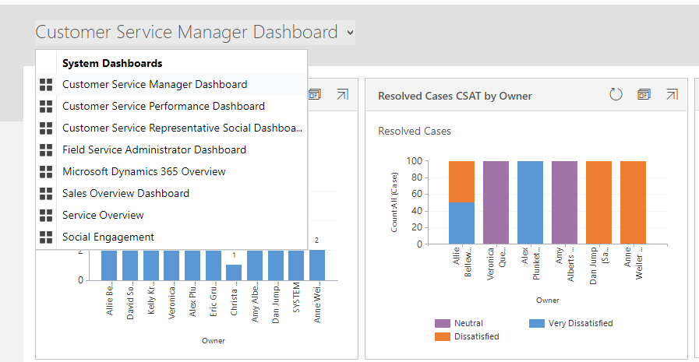

This user guide should have provided you with enough information to begin using Microsoft dynamics, if you possess any further enquiries about the software we recommend contacting Microsoft own support.